A
Mini Project Report
on

E-Commerce Shopping Cart System

Presented by
Buddhbhushan Kamble

SY[CSE]
Computer Science and Engineering
( 2025 – 2026 )

Guided By

Ms. D. S. Naik

(Department of Computer Science and Engineering)

Submitted to



MGM’s College of Engineering, Nanded

Under

Dr. Babasaheb Ambedkar Technological University, Lonere

Certificate
This is to certify that the mini project entitled
E-Commerce Shopping Cart System

Submitted By
Buddhbhushan Kamble

In satisfactory manner as a partial fulfillment of
SY[CSE] in Computer Science and Engineering

To

MGM’s College of Engineering, Nanded

Under
Dr. Babasaheb Ambedkar Technological University, Lonere
has been carried out under my guidance,

Ms. D.S Naik

Mini Project Guide

Dr. Mrs. A. M. Rajurkar Dr. Mrs. G. S. Lathkar
H.O.D Director
Computer Science & Engineering MGM’s College of Engg., Nanded

ACKNOWLEDGMENT

We are greatly indebted to our mini project guide, Ms. D. S. Naik, for her able guidance, and we would like to thank her for her help, suggestions, and numerous helpful discussions.
We gladly take this opportunity to thank Dr. A. Rajurkar (Head of Computer Science and Engineering, MGM's College of Engineering, Nanded).
We are heartily thankful to Dr. G. S. Lathkar (Director, MGM's College of Engineering, Nanded) for providing facilities during the progress of the mini project and for her kind guidance and inspiration.
Last but not least, we are also thankful to all those who helped directly or indirectly in the complete and successful development of this mini project.

With Deep Reverence,
Budhbhushan Maroti Kamble
SY [CSE]

ABSTRACT
The E-Commerce Shopping Cart System is a console-based Java application designed to simulate basic online shopping functionality. The system allows users to view available products, add selected products to a shopping cart, view cart contents, and calculate the total purchase amount.
The project focuses on implementing object-oriented programming concepts such as classes, objects, encapsulation, and collections using Java. It provides a menu-driven interface that is simple and user-friendly. This system helps students understand the basic workflow of an e-commerce application and serves as a foundation for developing advanced online shopping platforms.

Table of Contents

Acknowledgement |  | III
Abstract |  | IV
Table of Contents |  | V
List of Figures |  | VI
List of Tables |  | VII
Chapter 1. INTRODUCTION |  | 8
1.1 Problem Statement |  | 8
1.2 Objective of the Project |  | 8
1.3 Scope of the Project |  | 8
1.4 Existing System |  | 8
1.5 Proposed System |  | 8
Chapter 2. SYSTEM REQUIREMENTS |  | 9
2.1 Hardware Requirements |  | 9
2.2 Software Requirements |  | 9
Chapter 3. SYSTEM ANALYSIS |  | 9
3.1 Feasibility Study |  | 9
3.2 System Flow |  | 10
Chapter 4. SYSTEM DESIGN |  | 11
4.1 Use Case Diagram |  | 11
4.2 class Diagram |  | 11
4.3 Sequence Diagram |  | 12
4.4 Flowchart |  | 12
Chapter 5. IMPLEMENTATION |  | 13
5.1 Introduction to Implementation |  | 13
5.2 Program Structure |  | 13
5.3 Code Snippet |  | 14
5.4 Line-by-Line Explanation |  | 18
5.5 Description of Modules |  | 19
5.6 Sample Output Screenshot |  | 19
5.7 Working Procedure |  | 20
5.8 Summary  6. Testing  6.1 Test Cases  6.2 Input–Output Table  6.3 Validation Details  7. Results  7.1 Final Output  7.2 Module Screenshots  7.3 Performance |  | 20  21  21  21  21  22  22  23  23
8. Future Enhancement  Conclusion |  | 24  25
References |  | 25

List of Figures

Figure No. | Name of Figure | Page No.
1.1 | System Flowchart | 10
1.2 | Textual Use Case Diagram | 11
1.3 | Class Diagram | 12
1.4 | Flowchar | 12
1.5 | Sample Output Screenshot | 14

List of Tables
Table No. | Name of Table | Page No.
1.1 | Test Cases | 21
1.2 | Input–Output Table | 21

Chapter 1
Introduction
  - Problem Statement
The E-Commerce Shopping Cart System is a Java-based console application designed to simulate basic online shopping functionality. The system allows users to view a list of available products, add selected items to a shopping cart using product IDs, and view cart contents along with the total price. It uses object-oriented concepts such as classes, objects, constructors, and collections. The application is menu-driven, user-friendly, and continues execution until the user chooses to exit.
  - Objectives
- To understand object-oriented programming concepts in Java
- To develop a menu-driven shopping system
- To simulate real-world e-commerce operations
- To manage products and cart items efficiently
1.3 Scope
The project is limited to console-based interaction and does not include payment gateways or databases. However, it provides a strong foundation for further enhancement.

1.4 Existing System
Traditional shopping requires physical presence, consumes time, and limits product comparison.

1.5 Proposed System
The proposed system allows users to view products, add items to a cart, and calculate totals using a simple Java application.

Chapter 2
SYSTEM REQUIREMENT
2.1 Hardware Requirements
- Processor: Intel Core i3 or higher
- RAM: Minimum 2 GB
- Hard Disk: 20 GB or more free space
- Input Device: Keyboard
- Output Device: Monitor
- System Architecture: 32-bit or 64-bit
2.2 Software Requirements
- Operating System: Windows / Linux / macOS
- Programming Language: Java
- Java Development Kit (JDK): Version 8 or above
- IDE/Editor: Eclipse / NetBeans / IntelliJ IDEA / VS Code
- Java Runtime Environment (JRE)

Chapter 3

SYSTEM ANALYSIS

3.1 Feasibility Study
The E-Commerce Shopping Cart System is feasible to develop and implement using Java due to its simplicity and low resource requirements.
- Technical Feasibility:
The system is developed using Java, which is platform-independent and widely supported. Required technologies such as JDK, IDE, and basic Java libraries are easily available.

- Economic Feasibility:
The project is cost-effective as it uses free and open-source tools. No additional hardware or licensed software is required.

- Operational Feasibility:
The system is easy to operate through a menu-driven interface. Users can easily view products, add items to the cart, and check totals without any training
3.2 System Flow
The system follows a simple sequential flow:
- Start the application.
- Display main menu options (View Products, Add to Cart, View Cart, Exit).
- User selects an option.
- If “View Products” is selected, the product list is displayed.
- If “Add to Cart” is selected, the user enters a product ID and the item is added to the cart.
- If “View Cart” is selected, cart items and total price are displayed.
- The process repeats until the user chooses “Exit”.
- End the application

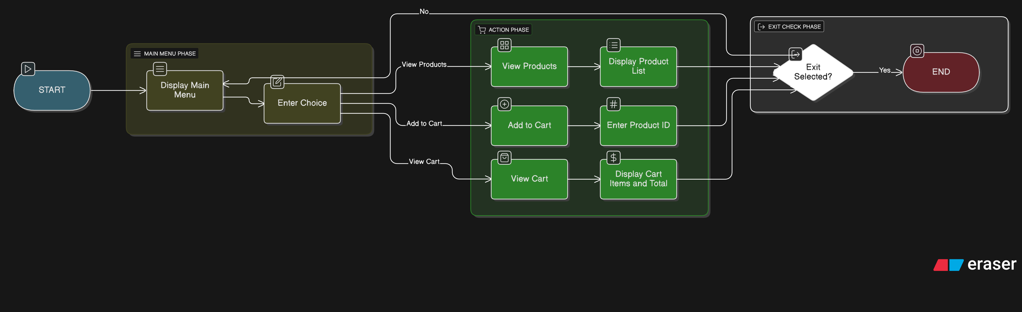

Chapter 4
System Design
4.1 Use Case Diagram
Actors:
- User – interacts with the system to browse products, add items to cart, and view cart.
Use Cases:
- View Products – Displays all available products.
- Add to Cart – User selects product to add to the shopping cart.
- View Cart – Shows cart items and total price.
- Exit System – Terminates the program.
Textual Use Case Diagram:
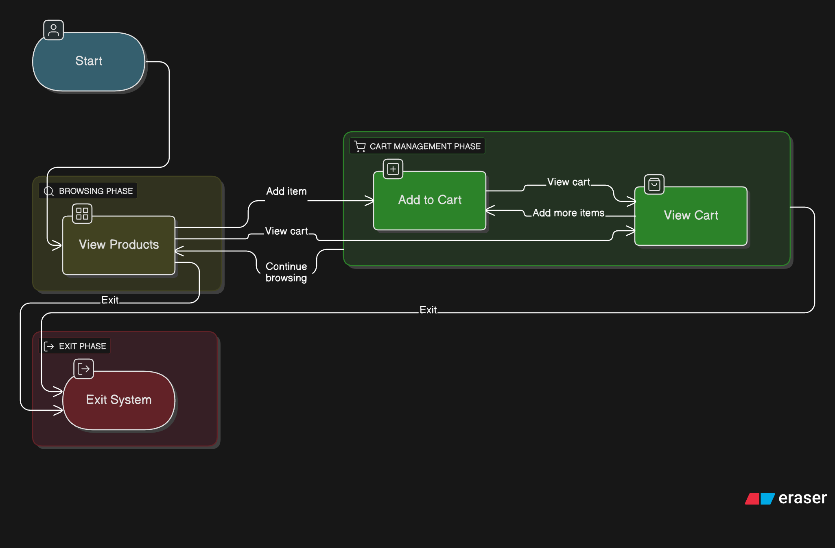
4.2 Class Diagram
Classes:
- Product
  - Attributes: id, name, price
  - Methods: display()
- Cart
  - Attributes: items (List<Product>)
  - Methods: addToCart(Product p), viewCart()
- Main
  - Handles user input and menu operations.Textual Class Diagram:
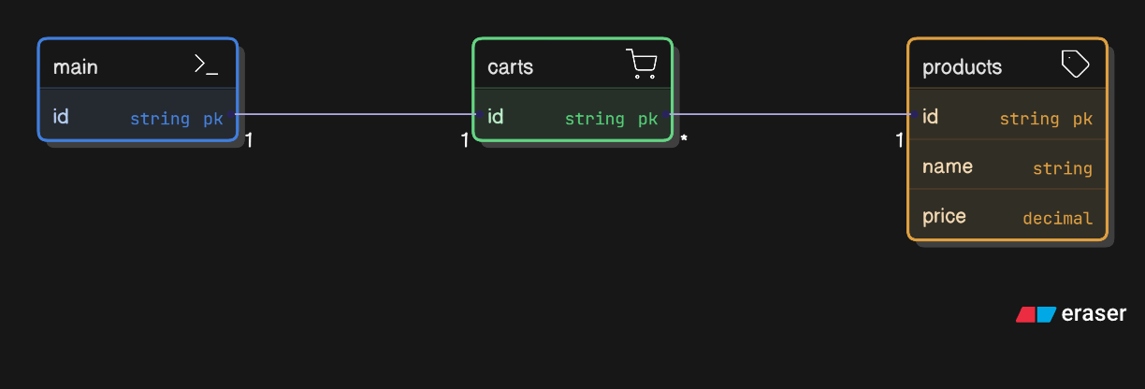
4.3 Sequence Diagram
Scenario: User adds a product to the cart.
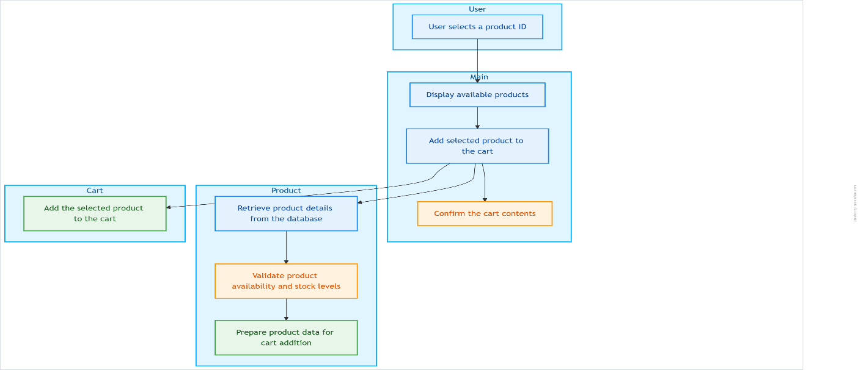4.4 Flowchar

Chapter 5

IMPLEMENTATION

5.1 Introduction to Implementation
Implementation is the phase where the theoretical design of the system is transformed into a working program. In this project, we implement a menu-driven E-Commerce Shopping Cart System using Java. The program allows users to view products, add items to a shopping cart, and view cart contents with the total price. Object-oriented concepts like classes, objects, constructors, and lists are utilized for efficient management.

5.2 Program Structure
The program consists of three main classes:
- Product – Represents individual products with attributes like ID, name, and price.
- Cart – Manages the shopping cart using a list to store selected products.
- Main – Contains the main method, handles user input, and provides a menu-driven interface.
Flow:
User → Main Menu → View Products / Add to Cart / View Cart → Repeat until Exit

5.3 Code Snippet

//PROJECT ON JAVA(E COMMERCE SHOPPING CART SYSTEM)
// Import necessary classes
import java.util.ArrayList;
import java.util.List;
import java.util.Scanner;

/* PRODUCT CLASS */
class Product {
int id;
String name;
double price;

// Constructor to initialize product details
Product(int id, String name, double price) {
this.id = id;
this.name = name;
this.price = price;
}

// Display product details
void display() {
System.out.println(id + ". " + name + " - Rs." + price);
}
}

/* CART CLASS - Stores selected products */
class Cart {
// List to store products added to cart
List<Product> items = new ArrayList<>();

// Add product to cart
void addToCart(Product p) {
items.add(p);
System.out.println(p.name + " added to cart.");
}

// View items in the cart
void viewCart() {
if (items.isEmpty()) {
System.out.println("Cart is empty.");
return;
}
System.out.println("\n--- Your Cart ---");
double total = 0;

// Display each item in cart
for (Product p : items) {
System.out.println(p.id + ". " + p.name + " - Rs." + p.price);
total += p.price;
}

// Display total price
System.out.println("Total: Rs." + total);
}
}

/* MAIN CLASS */
public class Main {
public static void main(String[] args) {
Scanner sc = new Scanner(System.in);

// Create a list of products (like database)
ArrayList<Product> products = new ArrayList<>();
products.add(new Product(1, "Mobile", 15000));
products.add(new Product(2, "Laptop", 55000));
products.add(new Product(3, "Headphones", 1200));
products.add(new Product(4, "Smart Watch", 2500));

// Create cart object
Cart cart = new Cart();

// Infinite loop for menu-driven system
while (true) {
System.out.println("\n--- E-Commerce Shopping System ---");
System.out.println("1. View Products");
System.out.println("2. Add to Cart");
System.out.println("3. View Cart");
System.out.println("4. Exit");
System.out.print("Enter choice: ");

int ch = sc.nextInt(); // User choice

switch (ch) {
// Display all products
case 1:
System.out.println("\n--- Product List ---");
for (Product p : products) {
p.display();
}
break;

// Add selected product to cart
case 2:
System.out.print("Enter product ID to add to cart: ");
int id = sc.nextInt();
boolean found = false;

// Search for product by ID
for (Product p : products) {
if (p.id == id) {
cart.addToCart(p);
found = true;
break;
}
}

// If product not found
if (!found) {
System.out.println("Invalid product ID!");
}
break;

// View cart items
case 3:
cart.viewCart();
break;

// Exit the program
case 4:
System.out.println("Thank you for shopping!");
return;

// Invalid menu choice
default:
System.out.println("Invalid choice!");
}
}
}
}

5.4 Line-by-Line Explanation

Product Class
- Defines attributes id, name, and price for each product.
- Constructor initializes product details when a new product object is created.
- display() method prints the product ID, name, and price to the console.
Cart Class
- Uses an ArrayList items to store products added to the cart.
- addToCart(Product p) method adds a product to the cart and confirms addition with a message.
- viewCart() method checks if the cart is empty.
  - If empty, it displays “Cart is empty.”
  - Otherwise, it lists all products in the cart and calculates the total price.
Main Class
- Scanner object is used to take user input from the console.
- An ArrayList products stores all available products in the system.
- Cart object cart is created to hold user-selected items.
Menu-Driven Loop
- Uses an infinite while(true) loop to repeatedly display the menu until the user chooses to exit.
- Menu options include: View Products, Add to Cart, View Cart, and Exit.
- User input is read and stored in variable ch.
Handling User Choices
- switch(ch) determines the action based on user choice:
  - Case 1: Displays the list of all available products.
  - Case 2:
    - Prompts the user to enter a product ID.
    - Searches the product list for the entered ID.
    - If found, adds the product to the cart; otherwise, displays “Invalid product ID!”.
  - Case 3: Calls viewCart() to display cart items and total price.
  - Case 4: Exits the program with a thank-you message.
  - Default: Handles invalid menu choices by displaying “Invalid choice!”
5.5 Description of Modules
Module | Functionality
Product Class | Stores product details (ID, name, price) and displays them.
Cart Class | Adds products to cart, displays cart items, calculates total.
Main Class | Handles user input, displays menu, manages program flow.

5.6 Sample Output Screenshot
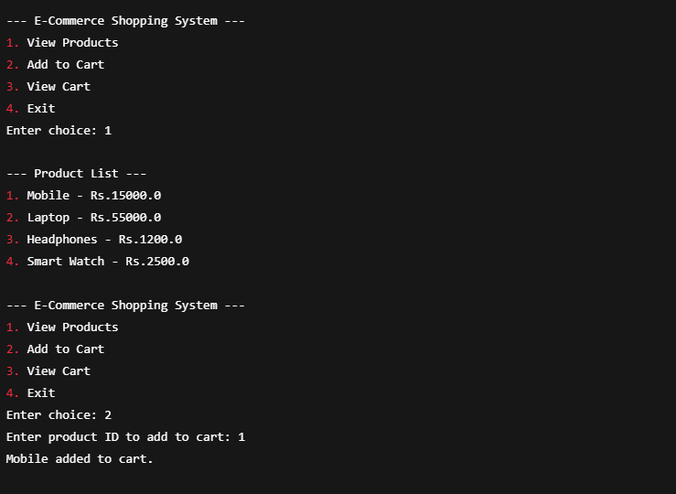
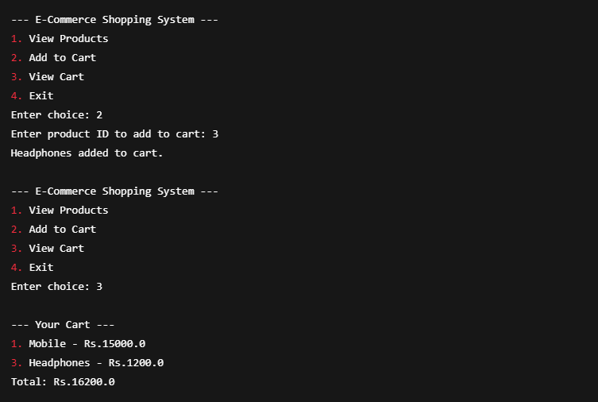
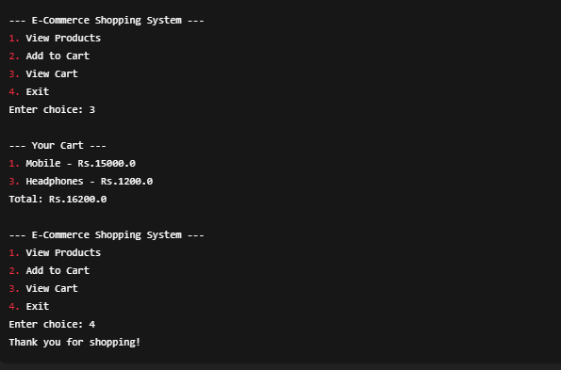

5.7 Working Procedure
- Run the Java program.
- Display the main menu to the user.
- User selects an option:
  - View Products → Display all available products.
  - Add to Cart → Enter product ID, item added to cart.
  - View Cart → Display cart items and total price.
  - Exit → Terminate the program.
- Repeat steps 2–3 until the user chooses Exit.
- End program execution
5.8 Summary
In this chapter, the implementation of the Java E-Commerce Shopping Cart System was discussed in detail. The system was designed using object-oriented principles with three main classes: Product, Cart, and Main. The program allows users to view products, add items to the cart, and check the total price using a simple menu-driven interface. Each module was explained with code snippets and line-by-line descriptions. Sample outputs demonstrated the system’s functionality, showing that the application works efficiently and meets the intended objectives.
Chapter 6
Testing
6.1 Test Cases
Test Case No. | Functionality | Input | Expected Output | Result
TC1 | View Products | 1 | Display all available products | Pass
TC2 | Add Product to Cart | 2 → Product ID: 1 | Mobile added to cart | Pass
TC3 | View Cart | 3 | Display items in cart & total price | Pass
TC4 | Invalid Product ID | 2 → Product ID: 10 | Invalid product ID! | Pass
TC5 | Invalid Menu Choice | 5 | Invalid choice! | Pass
TC6 | Exit Program | 4 | Thank you for shopping! | Pass

6.2 Input–Output Table
Input | Process | Output
Choice = 1 | View Products | Displays list of all products
Choice = 2, Product ID = 1 | Add product to cart | “Mobile added to cart”
Choice = 2, Product ID = 10 | Add product to cart | “Invalid product ID!”
Choice = 3 | View Cart | Shows all cart items and total price
Choice = 5 | Invalid menu option | “Invalid choice!”
Choice = 4 | Exit program | “Thank you for shopping!”
6.3 Validation Details
- Menu Choice Validation
  - Ensures user enters a valid menu option (1–4).
  - Invalid options display “Invalid choice!” and prompt user again.
- Product ID Validation
  - Ensures the entered product ID exists in the product list.
  - Invalid IDs display “Invalid product ID!”
- Cart Handling
  - Prevents adding non-existent products.
  - Displays total cost correctly each time a product is added.

Chapter 7
Results
7.1 Final Output
The final output of the system demonstrates a menu-driven E-Commerce Shopping Cart that allows users to:
- View all available products.
- Add selected products to the shopping cart.
- View the cart items along with the total price.
- Exit the program gracefully.
Sample Final Output (Console-Based):
--- E-Commerce Shopping System ---
1. View Products
2. Add to Cart
3. View Cart
4. Exit
Enter choice: 1

--- Product List ---
1. Mobile - Rs.15000.0
2. Laptop - Rs.55000.0
3. Headphones - Rs.1200.0
4. Smart Watch - Rs.2500.0

Enter choice: 2
Enter product ID to add to cart: 1
Mobile added to cart.

Enter choice: 3
--- Your Cart ---
1. Mobile - Rs.15000.0
Total: Rs.15000.0
Enter choice: 4
Thank you for shopping!

7.2 Module Screenshots
(For your project submission, take console screenshots of each module. Below is a textual representation.)
- View Products Module
1. Mobile - Rs.15000.0
2. Laptop - Rs.55000.0
3. Headphones - Rs.1200.0
4. Smart Watch - Rs.2500.0

- Add to Cart Module
Enter product ID to add to cart: 2
Laptop added to cart.

- View Cart Module
--- Your Cart ---
1. Mobile - Rs.15000.0
2. Laptop - Rs.55000.0
Total: Rs.70000.0
- Exit Module
Thank you for shopping!

7.3 Performance
- Efficiency: The system responds instantly to user inputs with minimal processing time.
- Reliability: Validates user inputs to prevent invalid product selection or menu choices.
- Scalability: Additional products can be added easily to the product list without changing the program logic.
- Usability: Menu-driven interface is simple and user-friendly for console-based interaction.

.

Chapter 8
Future Enhancement

The current E-Commerce Shopping Cart System is a basic console-based application. In the future, it can be enhanced in several ways to make it more robust, user-friendly, and closer to a real-world online shopping platform. Possible enhancements include:
- Graphical User Interface (GUI):
  - Implement a GUI using Java Swing, JavaFX, or similar frameworks to make the system visually appealing and easier to use.
- Database Integration:
  - Store products and cart information in a database (MySQL, SQLite, etc.) for permanent storage and dynamic management.
- Quantity Selection:
  - Allow users to select the quantity of products and calculate totals accordingly.
- User Authentication:
- Add login/signup functionality to manage multiple users and keep track of individual carts. Payment Gateway Integration:
  - Implement online payment processing to simulate real-world e-commerce transactions.
- Order Management System:
  - Generate invoices, order history, and shipment tracking for users.
- Search and Filter Options:
  - Enable users to search products by name, category, or price range for better usability.

Chapter 9
Conclusion
9.1 Summary of Achievements
The Java E-Commerce Shopping Cart System project successfully implements a basic online shopping experience using a console-based menu-driven interface. The system achieves the following:
- Displays a list of products with details such as ID, name, and price.
- Allows users to select products and add them to the shopping cart.
- Maintains a cart that stores selected items and calculates the total cost.
- Provides input validation for product IDs and menu choices .
- Demonstrates the use of object-oriented concepts such as classes, objects, constructors, and ArrayLists.
- Offers a simple, user-friendly, and efficient interface for interacting with the system.
9.2: Advantages
Simple and user-friendly
Uses OOP concepts
Easy to enhance
9.3: Limitations
No database
No payment system
Console-based only
References
- Oracle Java Documentation.
- Eck, D. Introduction to Programming Using Java, 3rd Edition, CreateSpace Independent Publishing, 2019.
- Oracle. The Java™ Tutorials. Available: https://docs.oracle.com/javase/tutorial/
- GitHub Repositories and Open-Source Java Projects (for learning concepts and ex)
- TutorialsPoint. Java Programming Language Tutorial. Available: https://www.tutorialspoint.com/java/index.htm
- W3Schools. Java Programming. Available: https://www.w3schools.com/java/

